1. Design DFA using simulator to accept the string the end with ab over set {a,b)

W= abbaabab

INPUT:

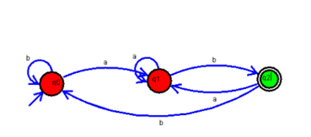

OUTPUT:

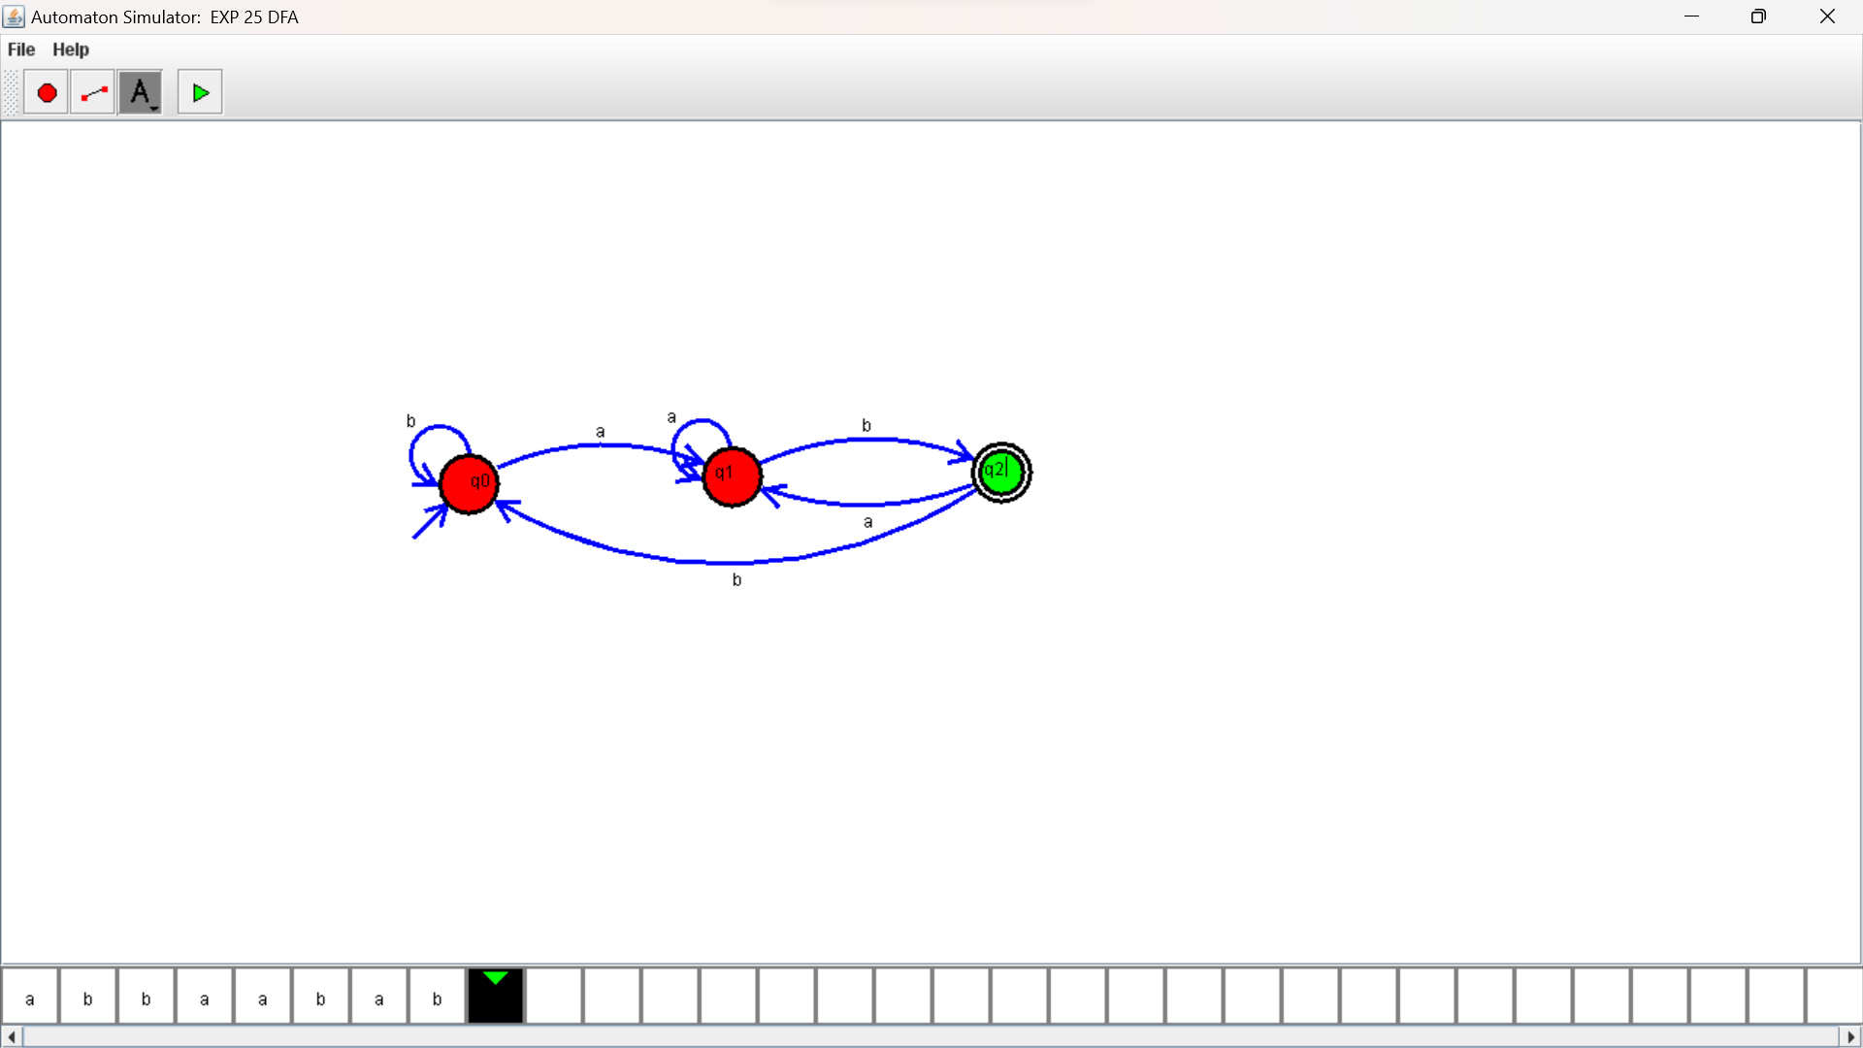

RESULTS:

Design DFA using simulator to accept the string the end with ab over set {a,b)

W= abbaabab